Homework 2
B00814692 Xianzhi Luo

I follow the TA’s suggestion in his email, first I build a server socket and bind it with the port 17777, and then use listen to wait for other clients to build connection, when the first connection is built, I use strstr to judge whether this is Alice or Bob, then I send the message base on the judgement.

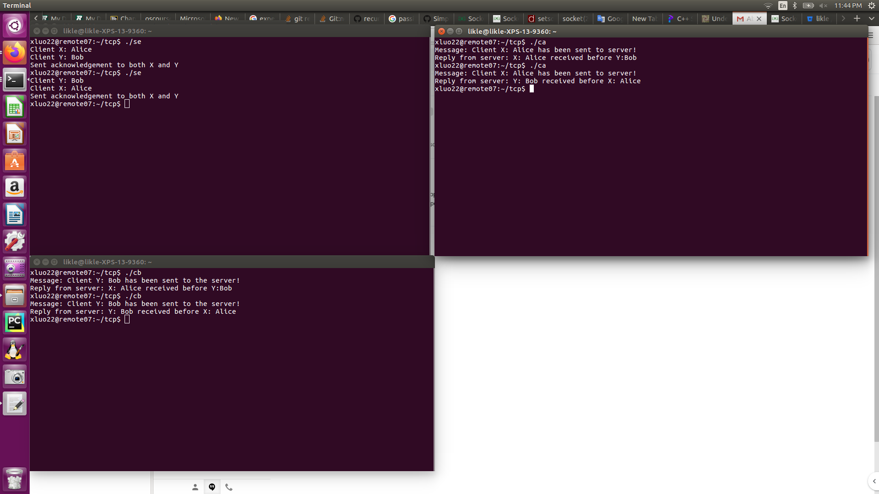

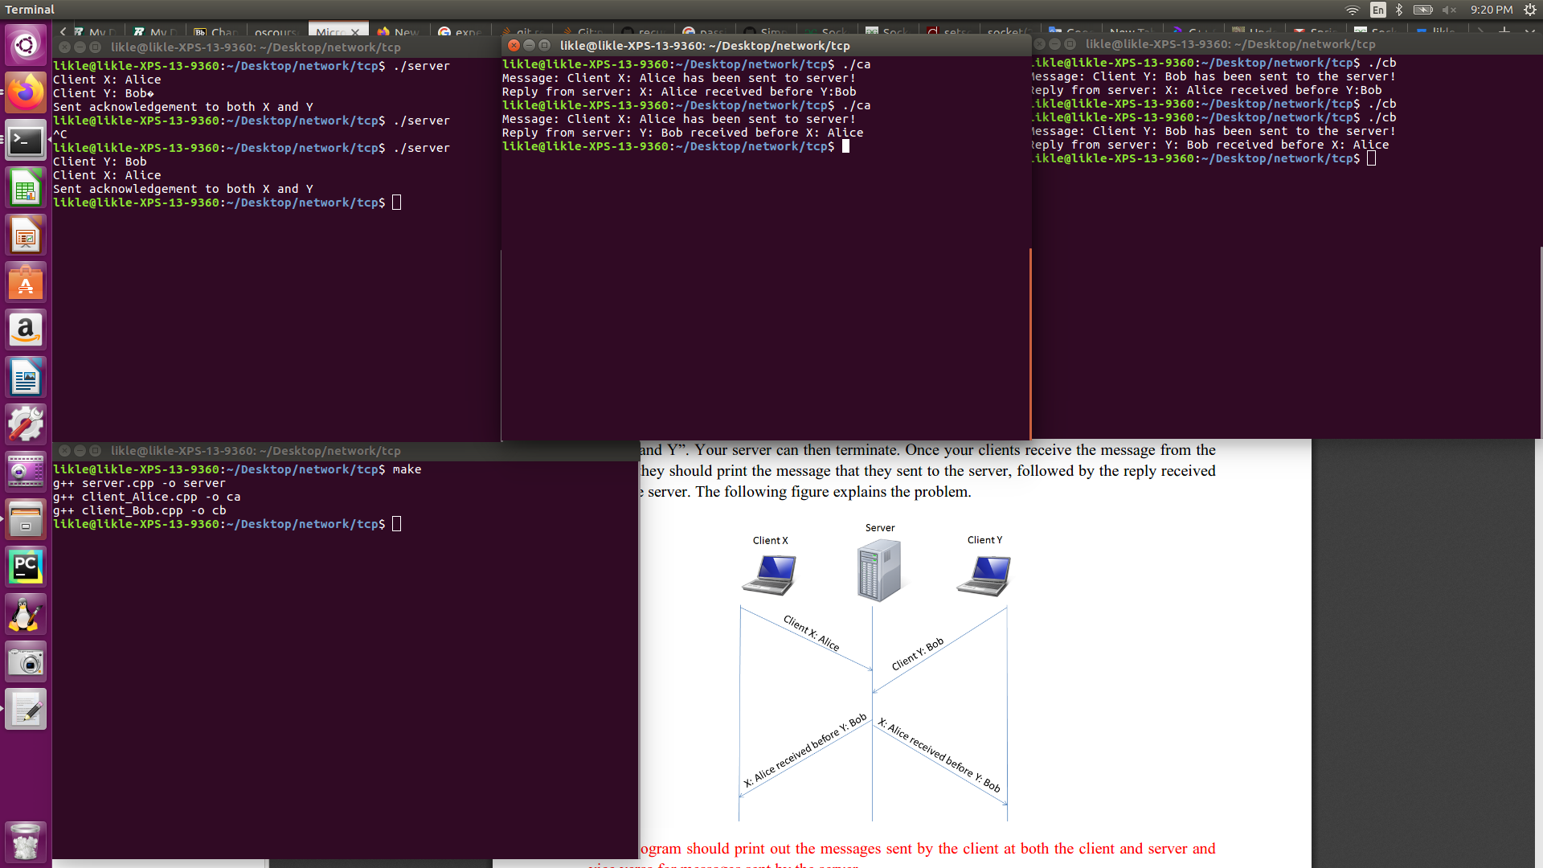
Here is the screenshot of result.

